
Welcome to Year 6

Dear Parent/Carer

We have put together lots of information about Year 6. It includes an overview of the learning we will be engaged in this term, some key things to remember and some ideas for things to do at home to support learning in school.

Year 6 Staff
Mr Withers – Cairns  Palm Class  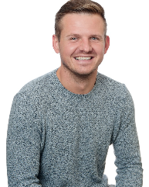 | Miss James  Juniper Class  
Miss Dickinson  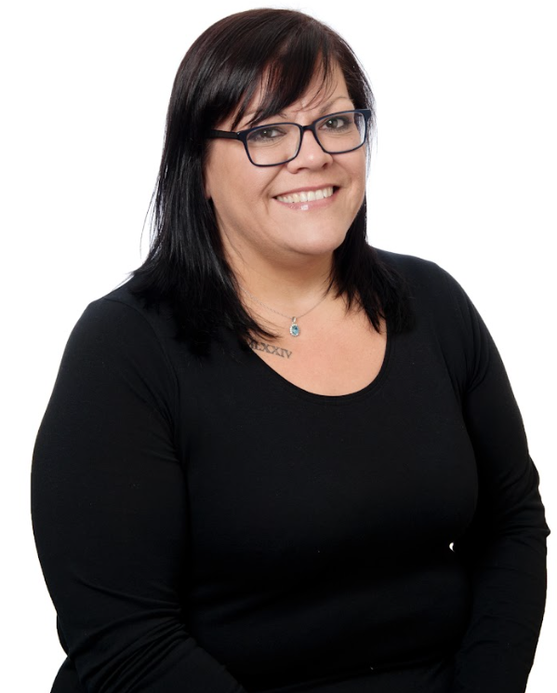 | Mrs Puc  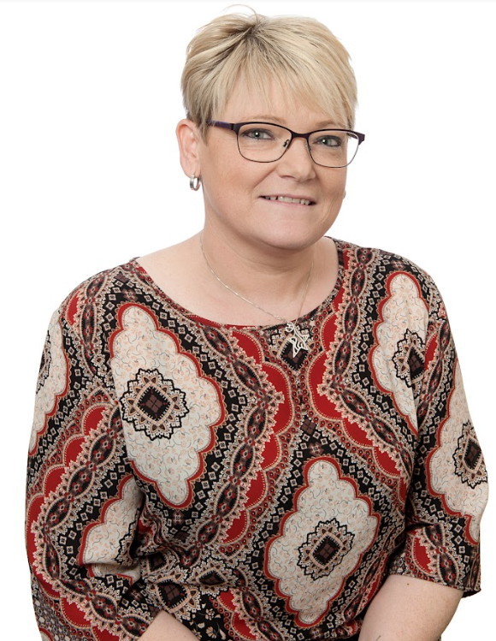 | Miss Cowell  

Things to remember
Monday and Wednesday – PE
(You can wear your own leggings/shorts and top as long as they are plain black and a plain white t-shirt) Children are allowed to wear their PE kits to school on PE days.
(They can bring a uniform to change into afterwards if they want.)
Friday - Library
Remember to bring your reading book and record with you each day - Log on to Bug Club
Remember to learn your multiplication tables - Log on to TTRockstars and enter the competitions
Ask your teacher for your username and password if you have forgotten it.
Remember to complete any homework set.

Homework tasks and fun activities
TTRockstars - https://play.ttrockstars.com/
Maths.co.uk – www.maths.co.uk
Spag.com – www.spag.com
Learn by Questions – www.lbq.org
Bug Club – www.activelearnprimary.co.uk

Learning in School
English | Text: The Lost Thing  Fiction - Character Description  Short Film - The Lost Thing  Fiction - Informal letter  Short Film - The Lost Thing | Text: Room 13  Fiction - Setting Description  Short Film - Dracula’s Whitby  Fiction - News Report  Short Film - Francis
Reading | Class Reader - Wonder  Reciprocal - A Tsunami Unfolds | Class Reader - Room 13  Reciprocal - The Star Outside My Window
Maths | Number – Place Value.  Number – Addition, Subtraction, Multiplication and Division. | Fractions.  Measurement - converting units.
Science | Living Things and their Habitats  Understanding how living things survive and the different habitats of living things. | Electricity and Renewable Energy  Understanding how electricity is created and used and how we can adapt to using renewable energy.
PSHE | Aaron Slater, Illustrator  Dyslexia  Perseverance  SEND | Marcus Rashford  Activism  Online  Online Safety  Racism
My Happy Mind | Meet Your Brain  Celebrate | Appreciate  Relate
Art | Craft and design:  Photo opportunity – creating different mediums of art through photography  Painting and mixed media:  Artist study – Looking at a range of artists and their styles
Music | Dynamics, Pitch and Texture  (Fingal’s Cave) | Songs of World War 2
History and Geography | WW2  What was the impact of World War II on the people of Britain?
DT | Textiles – Waistcoats  Using sewing skills to create a themed waistcoat.
Computing | Computing systems and networks  Exploring how data is transferred by working collaboratively online. | Creating Media  Designing and creating webpages, considering copyright, aesthetics and navigation.
PE | Football - Invasion Games  Ultimate Frisbee | Basketball - Invasion games  Gymnastics
RE | How can Brahman be everywhere and in everything? Sanatana Dharma | Do Christian celebrations and traditions help Christians understand who Jesus was and why he was born?

Key Dates
Monday 1st September - Teacher Training Day  Tuesday 2nd September - Teacher Training Day  Wednesday 3rd September - School opens  Friday 24th October - School closes for Half Term | Monday 3rd November - School opens  W/C Monday 24th November – Palm IntoUni Focus  W/C Monday 7th November – Juniper IntoUni Focus  Friday 19th December – School closes for Half Term

